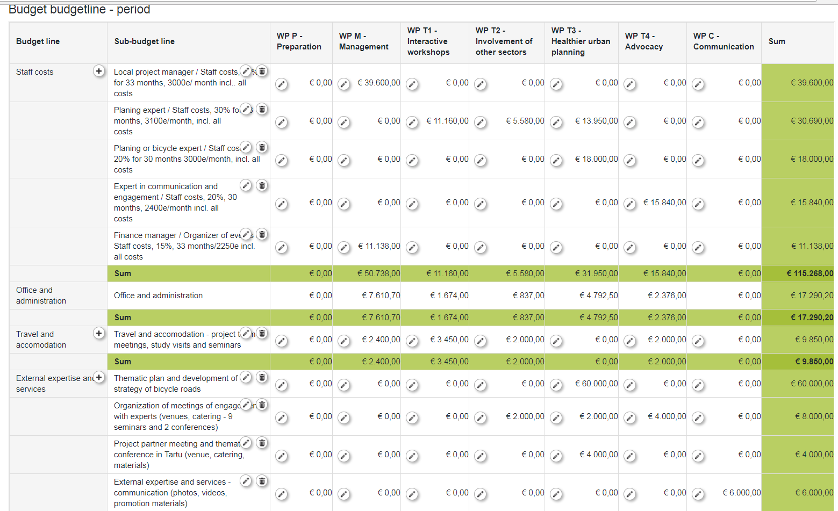
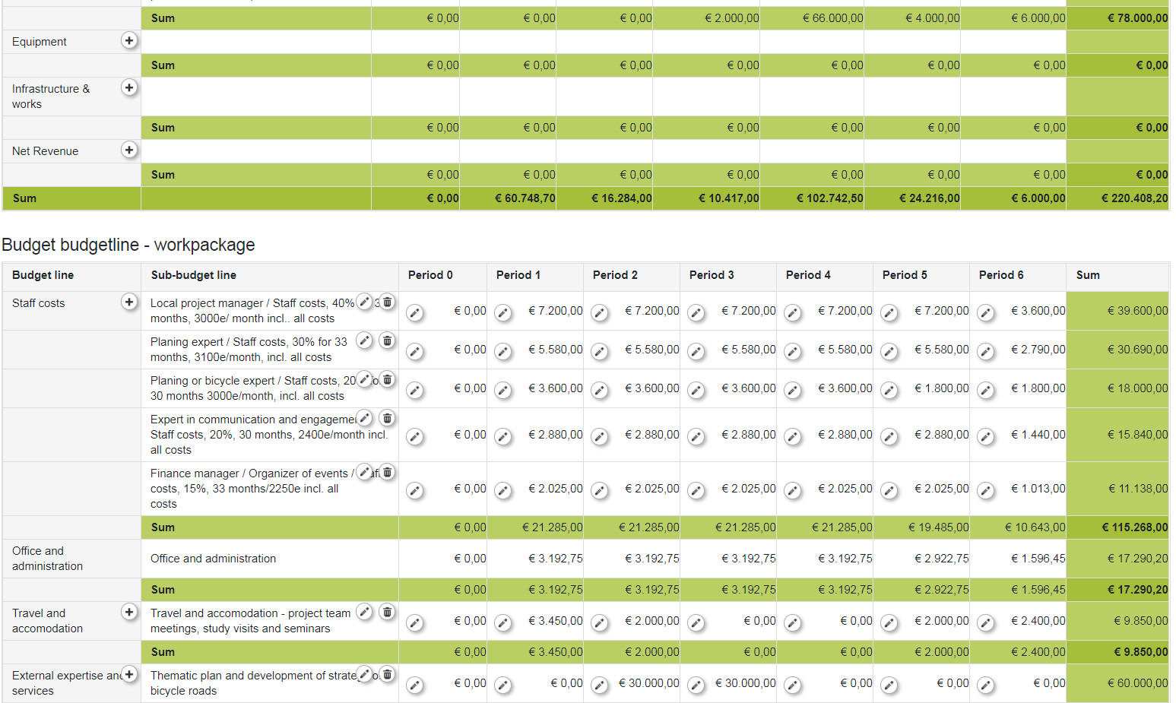

Comments from LP:
The following cuts were done in comparison to the original budget:
- the thematic plan: 60.000 instead of 65.000
- communication 6.000 instead of 10.000
- Project partner meeting and thematic conference: 4.000 instead of 9.000

